Psychology of Affect and Relationships - A biologically based theory of emotion
Last Seminar was on attachment and we learnt about how the quality of early relationships between infants and significant adult in their life leads to different types of attachment profile and explored the thoughts and behaviours associated with the different profiles.
The aim today is to look a little bit deeper into the biology of emotions to help us understand why it is important for us to care, and to also have a discussion about how positive professional relationships can make a difference.
________________________________________________________________
What is affect?
A biological programme hard wired into our central nervous system from birth. It is a brief biological response to stimulus conditions - with an evolved function of directing our attention to what is important for us to care about/focus our attention on.
The affect system in the brain consists of Nine affects (Silvan Tomkins 1962, 63). [SHOW AFFECTS ON CHART]
Each of the 9 affect is triggered when our sensory system perceives a certain signal in the environment around us
Each affect is triggered by very specific set of stimulus conditions. For example:
- Fear – terror – is response to our senses picking something too big, too loud or too fast.
- When our senses encounter a novel stimulus that is just right - interest- excitement is triggered.
- Distress –anguish - is the response triggered when too much has been happening for too long.
- Enjoyment-joy - is the affect triggered when that too much finally stops happening.
______________________________________________________________
Motivation and Cognitive System – Affects are the powerful motivators behind Learning
Affect motivates everything we think or do. We are all wired from birth to experience positive and negative affect based on stimulus conditions around us. We care - are motivated to automatically seek more positive feelings and to stop negative feelings.
The affect system works in conjunction with many other brain systems (cognitive systems). E.g. [Memory & ability to analyse and compare experiences]
Talk briefly about: Scene, Scripts, different theories, emotions.

Feelings – describes the situation when we become consciously aware that an affect has been triggered.
Emotions – scripted responses arising from our complex interaction between us and our social relationships and our brains motivational and cognitive systems effects on those interactions.
___________________________________________________________
EXAMPLE OF SCRIPT FORMATION
Hungry baby cries (Stimulus = hunger; Affect = distress; Response = crying)
Caregiver picks baby up, feeds her and she experiences relief of hunger (Stimulus = relief of hunger and distress; Affect = enjoyment-joy/contentment; Response = smile/body relaxes).
Each time this happens, cognitive system collects the scenes that are similar and organise them into groups and remembers them. As time passes, baby learns that every time she experiences distress a person appears to help reduce the negative affect of distress – whether created by hunger or something else.
Baby begins to have a great deal of interest in the appearance of that person and associate the person the general group known as people and the very specific person who attends always.

The affects of distress, enjoyment and interests are the powerful motivators behind this learning
Basic message of the script is that people help relieve my distress, give me enjoyment and are interested in me, and therefore I am interested in them.
The affects of distress, enjoyment and interests are the powerful motivators behind this learning
Basic message of the script is that people help relieve my distress, give me enjoyment and are interested in me, and therefore I am interested in them.

_______________________________________________________________
The how and why of caring and the primary motivation of all human behaviour is directed by the four rules of the blue print. [SHOW BLUEPRINT]
Well-being results from a life lived with 1-3 as much as circumstances permit. When this is the case no 4 progressively generates more and more advanced skills to carry out 1-3.
So our personality, the type of people that we are is determined by our scripted responses from past experiences – our theory of life. – In Attachment theory it is referred to as the internal working model.
Importance of Relationships - Shame
- So, Affect’s evolved function is to focus our attention on any impediment to our happiness/well-being
- I want to look at shame affect more closely – what triggers it? Let’s agree that its evolved function like the others is to focus our attention on anything that impedes our good feeling of joy-excitement.
- It turns out empirically that most of the experiences of interest and joy that get impeded have to do with social joining. So we think of shame as an interpersonal/interactional affect.
- Once positive affect is impeded, affect shame focuses attention on the impediment.
Now, the thing is what we see in the moment of shame is something in us that isn’t perfect – scripted emotions. Now maybe I am the only one in the room that has aspects of myself that isn’t perfect, but those of us who are perfect can understand the problems of the rest of us - that there are many areas that we feel insecure about.
Our innate reaction is to fulfil the requirement of the central blueprint which is to resolve the impediment to or feeling of joy-excitement and minimise shame.
We go through a brief moment where we feel awful, and then we decide – right are we going to pay attention to what shame has revealed?
Compass of shame
When we don’t know how to resolve the impediment that shame has brought to our attention, there are 4 universal systems of defence against the information shame wants us to consider. We shift to what we call the compass of shame. (William Nathanson)
The 4 poles of this compass are: [SHOW]
At each pole is a library of responses or scripts for things to say and do when shame strikes and we don’t know how to deal with it honestly.
Withdrawal
Different ways we try to conceal ourselves to prevent others from having what we feel is another reason to hold us in contempt - because some sort of weakness or defect has been exposed.
Attack self
This contains scripts that we can follow to show us how to accept the idea that only through a reduced status in life can we have any relationships at all.
Withdrawal and attack self poles produce peculiar and highly specific ways of living small – living a diminished life.
At the 2 remaining poles, we find contrasting sets of ways of handling shame.
Avoidance
Those that know that shame feels awful - but rather than look at where the spotlight of shame directs their attention they decide to evade the feeling to make it go away so they don’t have to pay attention – self-harm, sexualised behaviour, drugs, alcohol
Attack others
Those that get into the situation in which self deprecation or avoidance hasn’t worked and they engage in behaviours aimed at reducing the self-esteem of someone else to turn the tables to make the other person feel awful.
So What
Affects trigger themselves, so that what is triggered in me triggers the same in someone that I am dealing with – which is why emotion is contagious.
Knowing this and thinking of children who we work with who we feel have impediment to their excitement and joy
- How can we help them maximise positive affect and minimise negative affects through our relationship with them directly and/or with their wider social systems?

Despite ongoing focus on how to promote better inclusion for the most vulnerable children and young people in UK schools, the evidence continues to show that more needs to be done for this group

While the most recent government statistics on school exclusion for 2020/21 show a drop in the rate of permanent exclusion compared to the previous year (0.10 to 0.06), further scrutiny of the data paints a different picture, as the observed reduction reported appears to have been driven by the effect of the national lockdown that started in the Spring term of the 2019/20 academic year. Looking at the Autumn term figures, alone, shows that permanent exclusions actually increased by 20% in primary schools and 3% in secondary schools (77 permanent exclusions respectively) (DfE, 2021). As with previous years, the DfE data shows that children and young people (CYP) from low socioeconomic status background (SES) and those with learning difficulties are disproportionately represented in the exclusion figures, with exclusion rates being highest among CYP with social, emotional, and mental health needs (SEMH).

A review of 13 qualitative studies with excluded children by Apland and colleagues in 2017, noted that participating CYP made links between their behaviour and challenging home lives (Apland et al., 2017). Despite increasing acknowledgement of the links between challenging behaviour problems and CYP’s background, interventions tend to home in on crime reduction or reducing rates of exclusion, instead of a focus on consistent and integrated welfare-led approaches that promote inclusion for vulnerable CYP (Commission on Young Lives, 2022).

My thesis

ASP provides a useful framework for understanding, responding, and supporting struggling CYP to get back on track. Through having awareness of the affect at play and understanding that challenging behaviour can be CYP’s attempt to by-pass the shame affect triggered from inability to access learning and social opportunities, teachers are more likely to respond with empathy, look beyond presenting behaviour, and strive to develop safe, nurturing, and trusting relationships which allows them to foster resilience in their students. Responding with empathy minimises the potential chances of negative affects being amplified, with the by-product being a rekindling of CYP’s interest because of the interest shown by the teacher in understanding that their presenting behaviour is driven by an underlying need that needs to be met. It is only then that support strategies aimed at rekindling CYP’s interest in the subject are likely to be effective. Developing trust through empathic response allows teachers the opportunity to model adaptive coping strategies that support struggling CYP to develop their own set of coping strategies to help get them back on track. George (2014) describes this type of coaching in cognitive strategies as “an apprentiship model of pedagogy, in which the teacher (the expert/master) inducts the student (the apprentice/novice) into the cognitive process employed in the particular subject context in question” (p.224). The sequence of complex learning through adaptively by-passing the spotlight highlighted by the triggering of negative affects such as shame is summarised diagrammatically in

The process of complex learning (George, 2014: p.224)
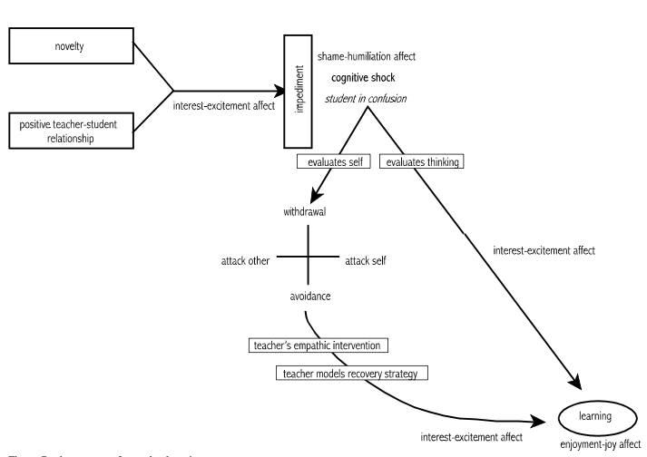

Through empathic listening and response, the teacher can encourage struggling CYP to minimise the inhibition of negative affect through working collaboratively to explore, acquire, and master adaptive cognitive strategies that foster competence when faced with and responding to challenges (Shane, 1980).
It is important to understand that CYP for whom their social, personal, interpersonal, and learning experiences have been a regular source of unresolved negative affect, are more likely to default to using one or more of the sets of scripts on the compass of shame, since they are likely to anticipate shame from engagement in learning and/or social activities, so that it makes more sense for them to draw on the avoidance script to help maximise positive affect and minimise negative affect. Learning inevitably involves failure which invariably triggers shame affect. Since the learning process can never be free of shame affect, what is important for children who have suffered long-term trauma is to build their resilience towards shame affect triggered because of interpersonal engagement. Carol Dweck’s work on mindset can be drawn upon to assist CYP in developing scripts involving greater resilience in responding to challenges. Empathic response from teachers allows CYP to separate evaluation of the self from evaluation of their behaviour and this can be a key ingredient in helping them to rewrite adaptive scripts (see Dweck, 2012 for more detailed discussion on different types of mindset and associated implications for motivation). It is intuitive that teachers’ ability to model positive responses and support strategies when shame affect is triggered in their own learning is an effective strategy in helping CYP to rescript themselves and avoid anticipatory shame that can cripple their interest and excitement in learning and impede opportunities for experiencing the joy and enjoyment associated with success.

